Name : K Jahnavi
Reg no: 192512169
Ex.No. 15: AI-based Traffic Prediction for 5G Networks
AIM: To develop and simulate an AI-based traffic prediction model for 5G networks using MATLAB and evaluate its performance in terms of Prediction Accuracy (%), Mean Squared Error (MSE), and Network Throughput (Mbps).
Objective:
1. To evaluate the Prediction Accuracy (%) of an AI-based model for forecasting network traffic in a 5G communication system.
2. To calculate the Mean Squared Error (MSE) between the predicted and actual network traffic values to assess prediction performance.
3. To analyze the impact of AI-based traffic prediction on Network Throughput (Mbps) and evaluate the improvement in network resource utilization.
Procedure:
clc; clear; close all;
% Time samples
t = 1:10; % Prediction Accuracy (%)
Accuracy = [90 91 92 93 94 95 96 97 98 99];
% Actual Network Traffic (Mbps)
Traffic = [45 50 55 60 65 70 75 80 85 90];
figure
% -------- Graph 1 --------
subplot(2,1,1)
plot(t,Accuracy,'-o','LineWidth',2)
title('AI Prediction Accuracy over Time')
xlabel('Time Interval')
ylabel('Prediction Accuracy (%)')
grid on
% -------- Graph 2 --------
subplot(2,1,2)
bar(Traffic)
title('Network Traffic Samples Used for AI Prediction')
xlabel('Traffic Sample')
ylabel('Traffic (Mbps)')
grid on
Output:
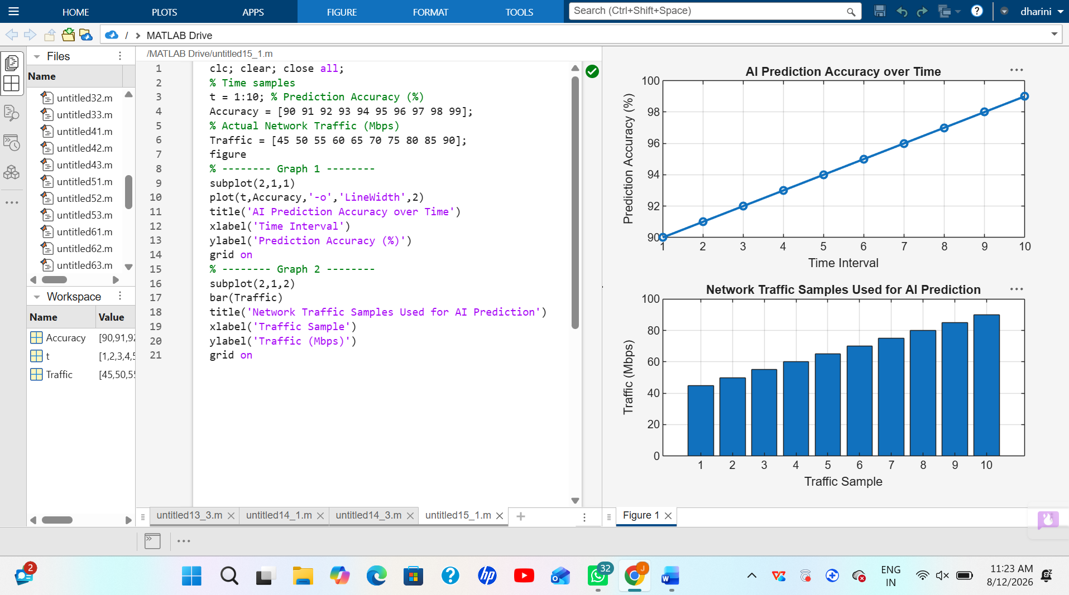
Objective 2:
clc; clear; close all;
% Time intervals
t = 1:10; % Actual and Predicted Traffic (Mbps)
Actual = [50 55 60 62 68 70 75 80 85 90];
Predicted = [49 54 61 63 67 71 74 81 84 89];
% Squared Error
SqError = (Actual - Predicted).^2;
% Mean Squared Error
MSE = mean(SqError);
disp(['Mean Squared Error (MSE) = ', num2str(MSE)])
figure
% -------- Graph 1 --------
subplot(2,1,1)
plot(t,SqError,'-o','LineWidth',2)
title('Squared Error of AI Traffic Prediction')
xlabel('Time Interval')
ylabel('Squared Error')
grid on
% -------- Graph 2 --------
subplot(2,1,2)
bar([MSE])
title('Mean Squared Error (MSE)')
xlabel('AI Prediction Model')
ylabel('MSE')
grid on

Output:
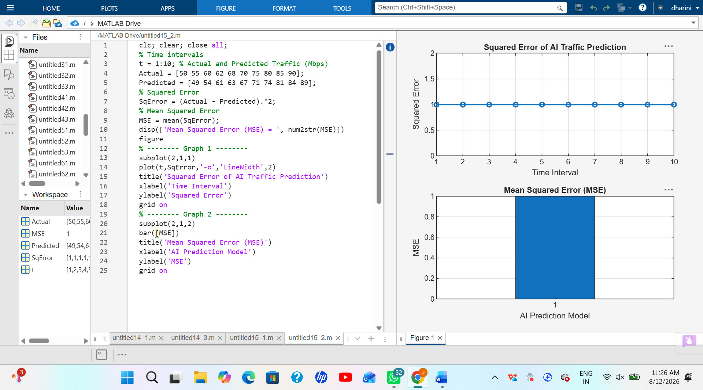
Objective 3:
clc; clear; close all;
% Time intervals
t = 1:10; % Network Throughput (Mbps)
Throughput = [120 135 150 165 180 195 210 225 240 255];
% Network Utilization (%)
Utilization = [60 65 70 74 78 82 86 90 94 98];
figure
% -------- Graph 1 --------
subplot(2,1,1)
plot(t,Throughput,'-o','LineWidth',2)
title('AI-Based Network Throughput')
xlabel('Time Interval')
ylabel('Throughput (Mbps)')
grid on
% -------- Graph 2 --------
subplot(2,1,2)
plot(Throughput,Utilization,'-s','LineWidth',2)
title('Throughput vs Network Utilization')
xlabel('Network Throughput (Mbps)')
ylabel('Network Utilization (%)')
grid on
disp('Time Throughput(Mbps) Utilization(%)')
disp([t' Throughput' Utilization'])
Output:
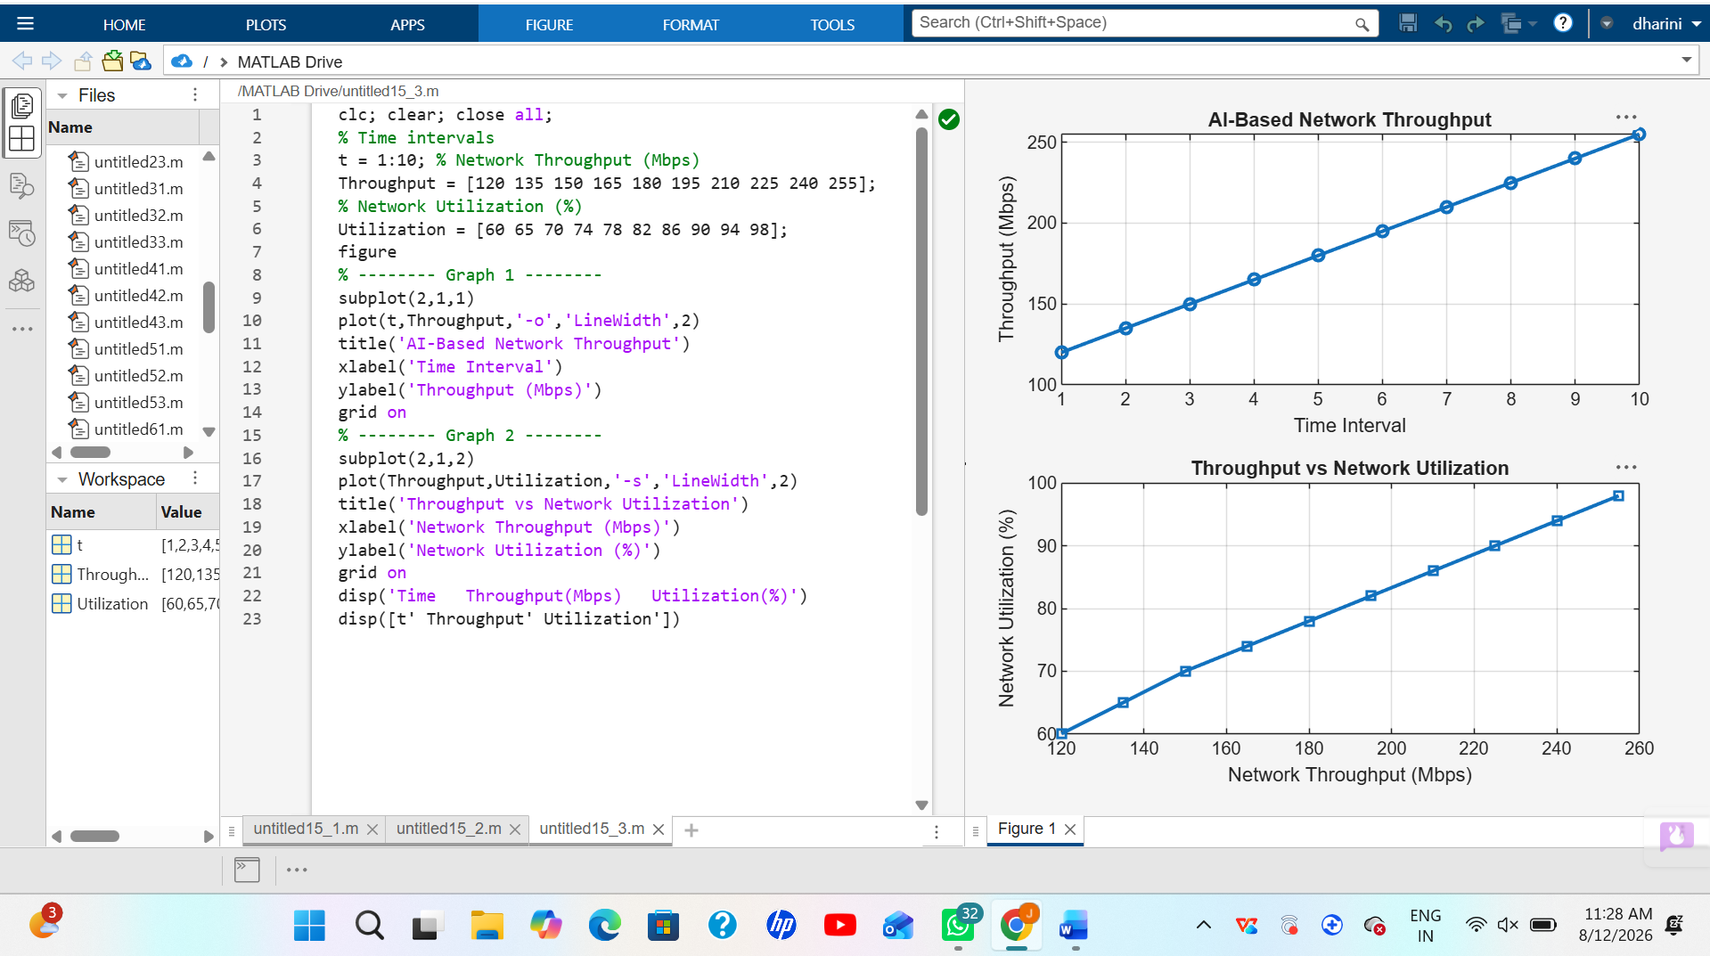
Result:
1. The AI-based traffic prediction model achieved high Prediction Accuracy (%), demonstrating its effectiveness in forecasting 5G network traffic patterns.
2. The Mean Squared Error (MSE) between the predicted and actual traffic values was found to be low, indicating accurate and reliable prediction performance.
3. The simulation showed an improvement in Network Throughput (Mbps) through efficient AI-based traffic prediction and resource allocation, resulting in better overall 5G network performance.

